Car Sold

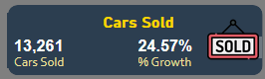

-Car Sold

Select

Year(Date) AS _Year,

COUNT([Company]) AS Cars_Sold

From SQLToturial.dbo.cars

Group by Year(Date)

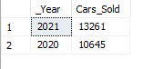

-%Growth

;with YTY_Cars_Sold As

(

Select

YEAR(date) as _Year,

Count(Company) As Cars_Sold

from SQLToturial.dbo.cars

Group by YEAR(date)

),

YTY_Prev_Sold As

(

Select

_Year,

Cars_Sold,

LAG(Cars_Sold,1,Cars_Sold)Over(Order by _Year) Priv_Sold

From YTY_Cars_Sold

)

select

PS.*,

ConCat(CAST(PS.Cars_Sold-PS.Priv_Sold AS Money) /PS.Priv_Sold*100 ,'%') As Growth

From YTY_Prev_Sold PS

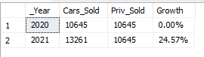

AVG Sales

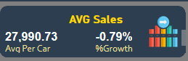

-Avg PerCar

Select Year(date)As date,Cast(AVG([Price ($)])AS decimal(8,2)) AS Sales

From SQLToturial.dbo.cars

Group By Year(date)

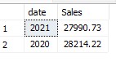

-%Growth

With Gr AS (

Select YEAR(Date) As Date,Cast(Avg([Price ($)])AS Decimal(8,2)) As Sales

From SQLToturial.dbo.cars

Group by Year(Date)

),

Gr1 AS(

Select *,Lag(Sales,1,Sales)over(order by Date) As Prive_sales

From Gr

)

Select *,Concat(CAST((Sales - Prive_sales )/Prive_sales*100 AS decimal(12,2)),'%')AS YTY_Grwoth

From Gr1

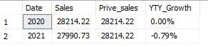

Sales

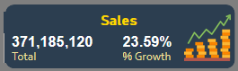

-Total

Select Year(Date)As Date,Sum([Price ($)])AS Total

From SQLToturial.dbo.cars

Group by Year(Date)

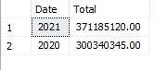

-%Growth

with Prive_Sales As(

Select Year(Date) As Date,Sum([Price ($)]) As Sales

From SQLToturial.dbo.cars

Group by Year(Date)

),

Growth AS(

Select *,LAG(Sales,1,Sales)over(order by Date) As Sal_Priv

From Prive_Sales

)

Select *, Concat(Cast((Sales-Sal_Priv)/Sal_Priv*100 As Decimal(12,2)),'%')As YTY_Growh

From Growth

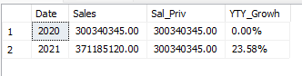

Sales By Color

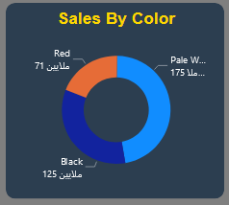

Select Year(Date) AS Year,Color,Sum([Price ($)]) As Sales

,(Select Sum([Price ($)]) From SQLToturial.dbo.cars) AS Total_Sales

From SQLToturial.dbo.cars

Group by Year(Date),Color

Order By Year(Date),Color

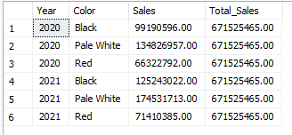

Sales By Type Car

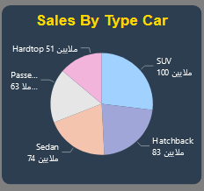

Select Year(Date) As Year,[Body Style],Sum([Price ($)]) As Sales

,(Select Sum([Price ($)]) From SQLToturial.dbo.cars) As Total_Sales

From SQLToturial.dbo.cars

Group by Year(Date),[Body Style]

Order by Year(Date),[Body Style]

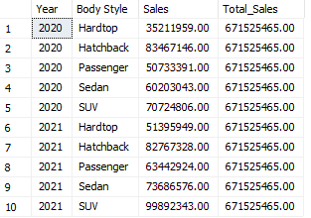

Weekly Sales

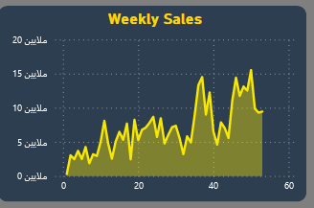

Select Year(Date) As Year

,DatePart(WEEK,Date) As Weekly

,Sum([Price ($)]) As Sales

From SQLToturial.dbo.cars

Group by Year(date),DatePart(WEEK,Date)

Order By Year(date),DatePart(WEEK,Date)

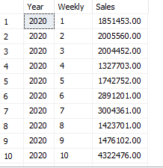

Details All Sales Type Car 2021

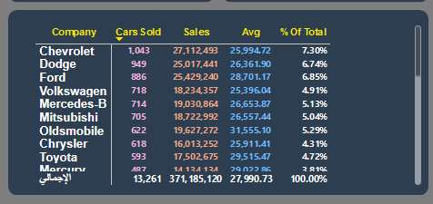

Select Company

,Count(Company)AS Car_Sold

,Sum([Price ($)])AS Sales

,Avg([Price ($)]) As AVG_Per_Car

,Concat (Sum([Price ($)])/(select Sum([Price ($)]) From SQLToturial.dbo.cars

Where Year(Date)='2021')*100 ,'%') AS '%Of_Total'

From SQLToturial.dbo.cars

where YEAR(Date)='2021'

Group by Company

Order by 2 DESC

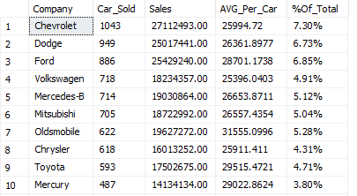

Sales By Region And Transmission

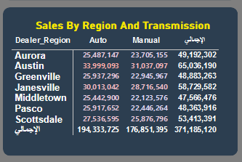

Select Year(Date) As Date

,Dealer_Region

,Transmission

,Sum([Price ($)]) AS Sales

From SQLToturial.dbo.cars

Group by YEAR(Date),Dealer_Region,Transmission

order By YEAR(Date),Dealer_Region,Transmission

